NOTE: Print at 600 dpi or higher. If printing at less than 600 dpi, use of preprinted letterhead from Warehouse is recommended.

Land Mammals
of San Luis Obispo Coast District State Parks

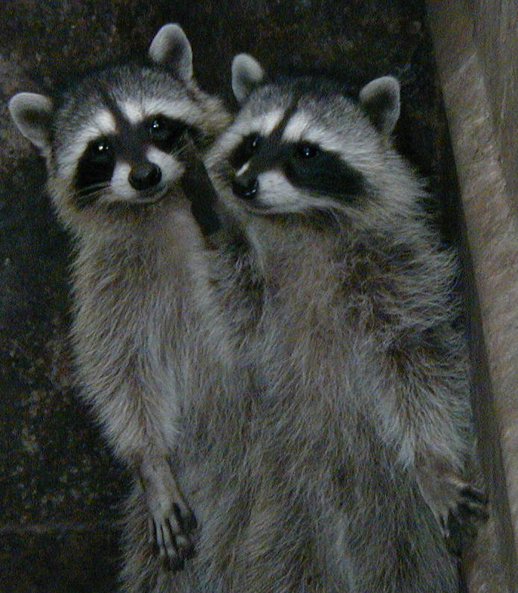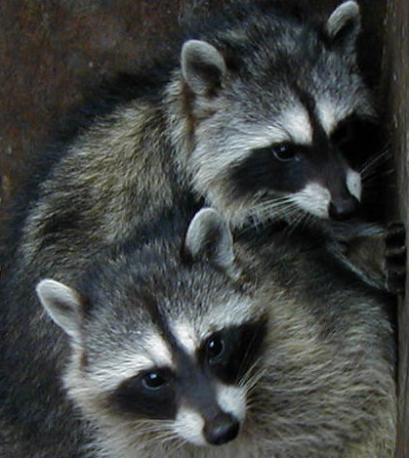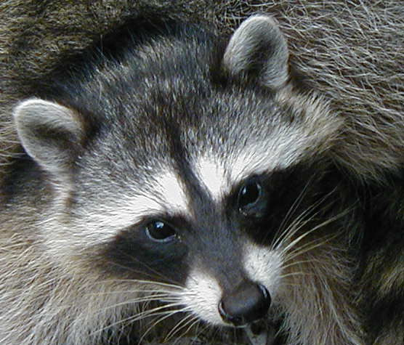
Procyon lotor (Common Raccoon)
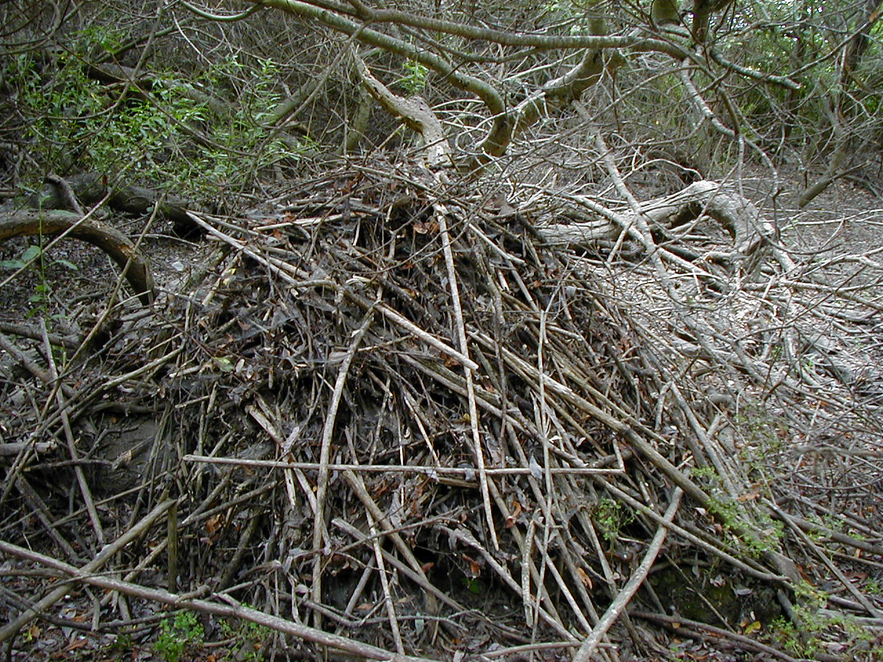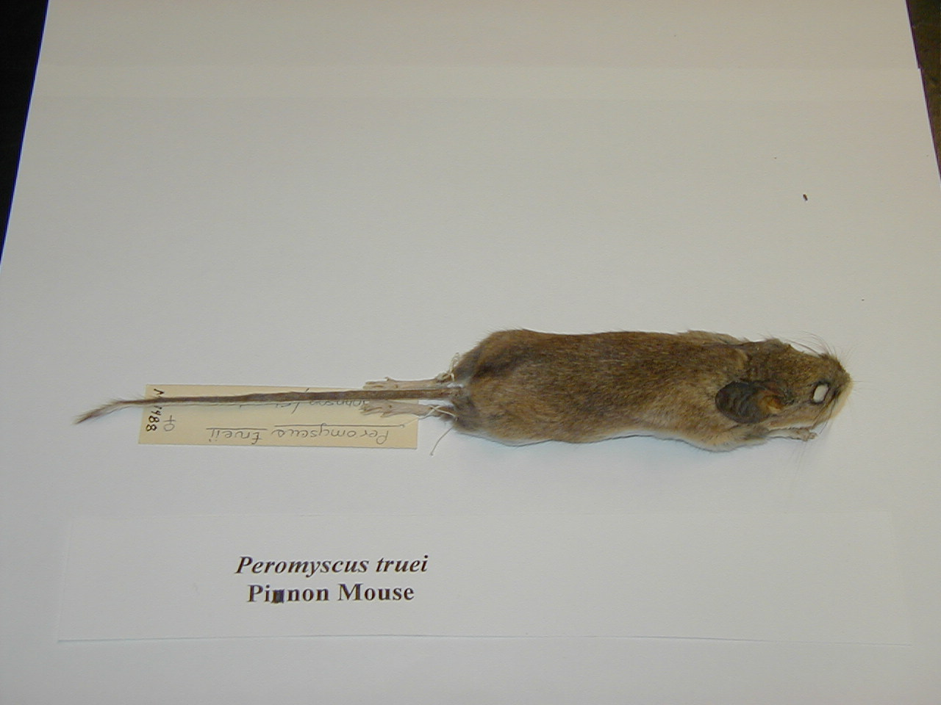
Neotoma fuscipes (Dusky-Footed Woodrat House) Peromyscus truei (Pinon Mouse)
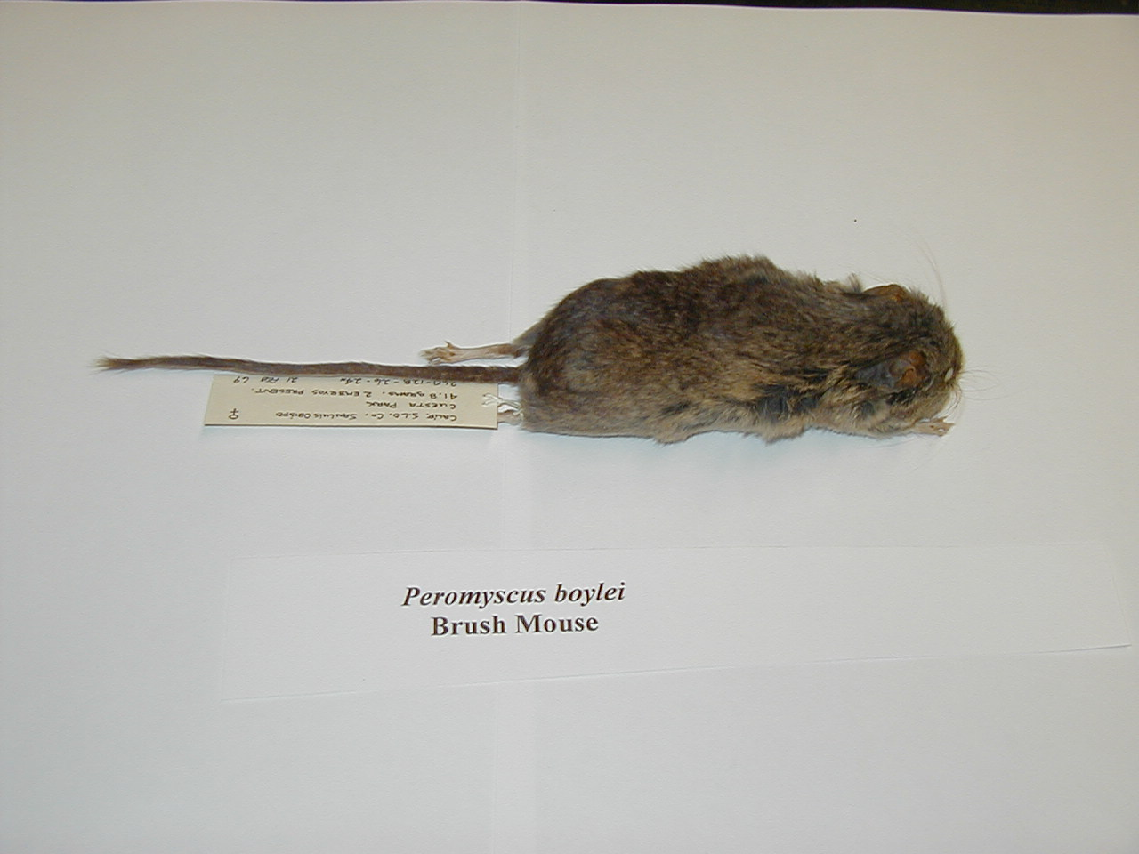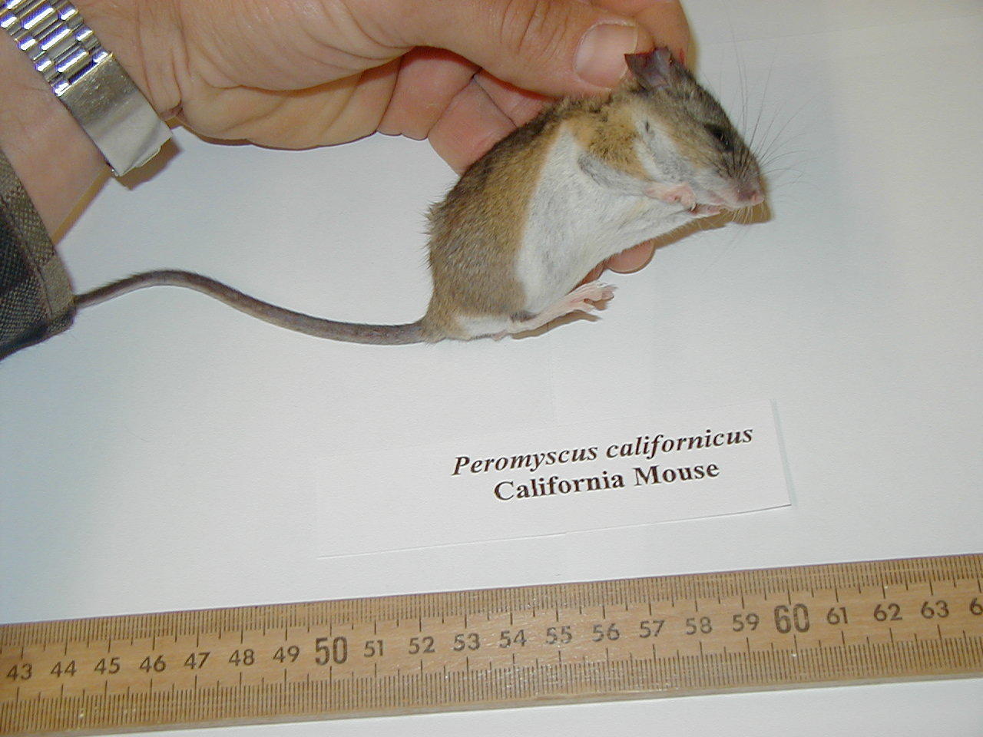
Peromyscus boylei (Brush Mouse) Peromyscus californicus(California Mouse)
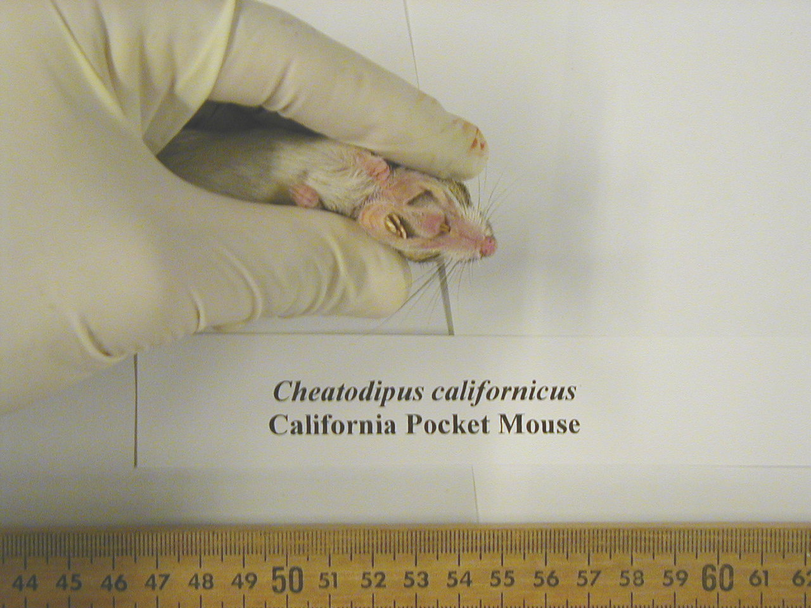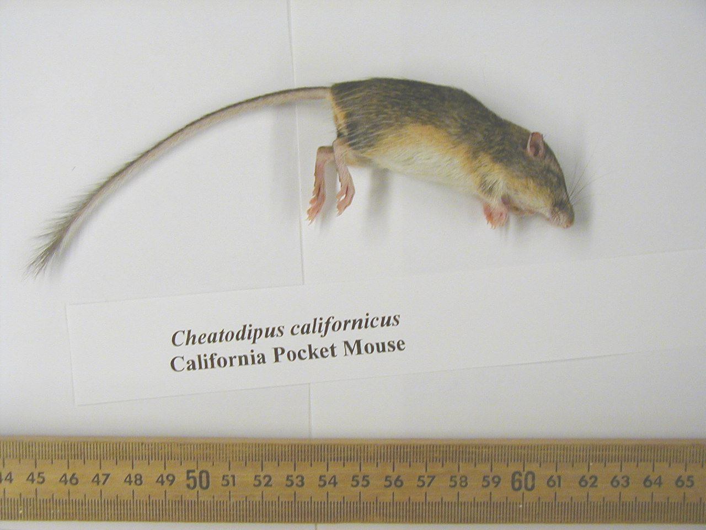
Cheatodipus californicus(View of Pouches) Chaetodipus californicus(Ca.Pocket Mouse)
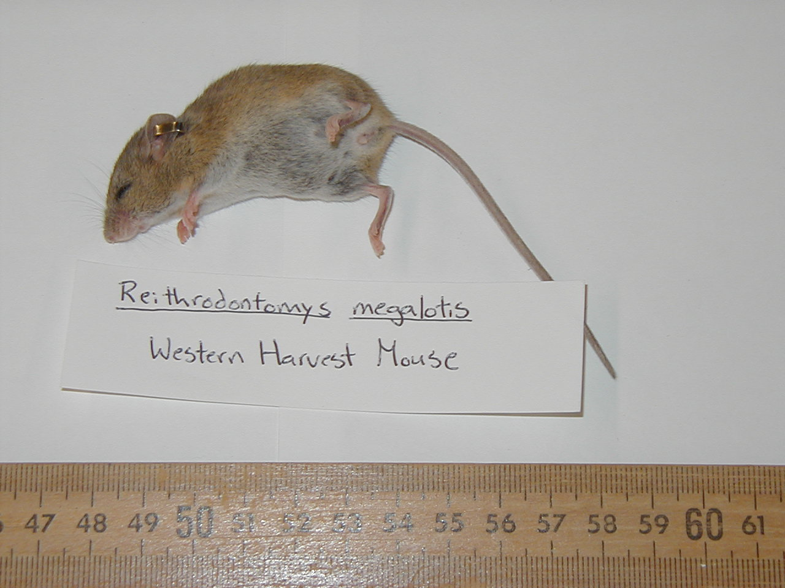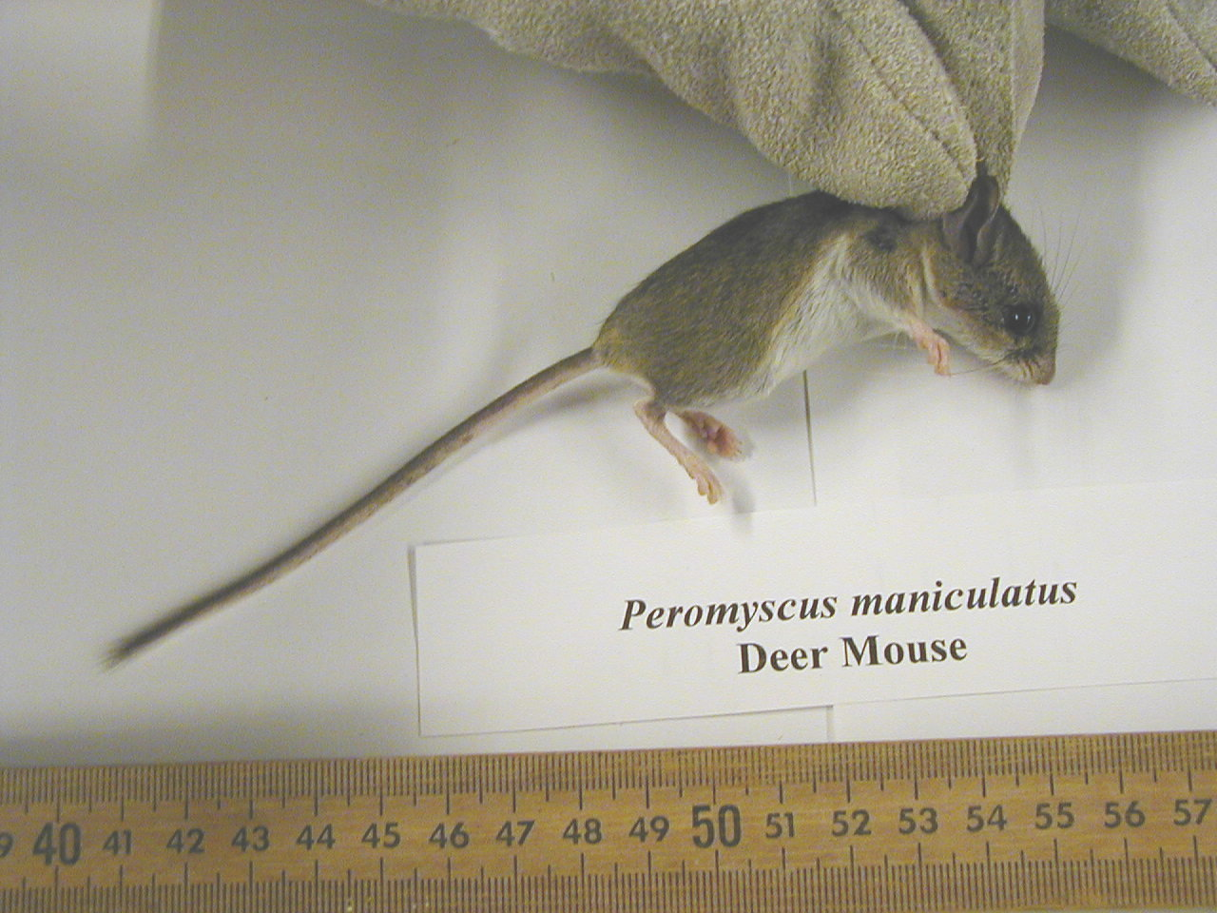
Reithrodontomys megalotis(W.Harvest Mouse) Peromyscus maniculatus (Deer Mouse)
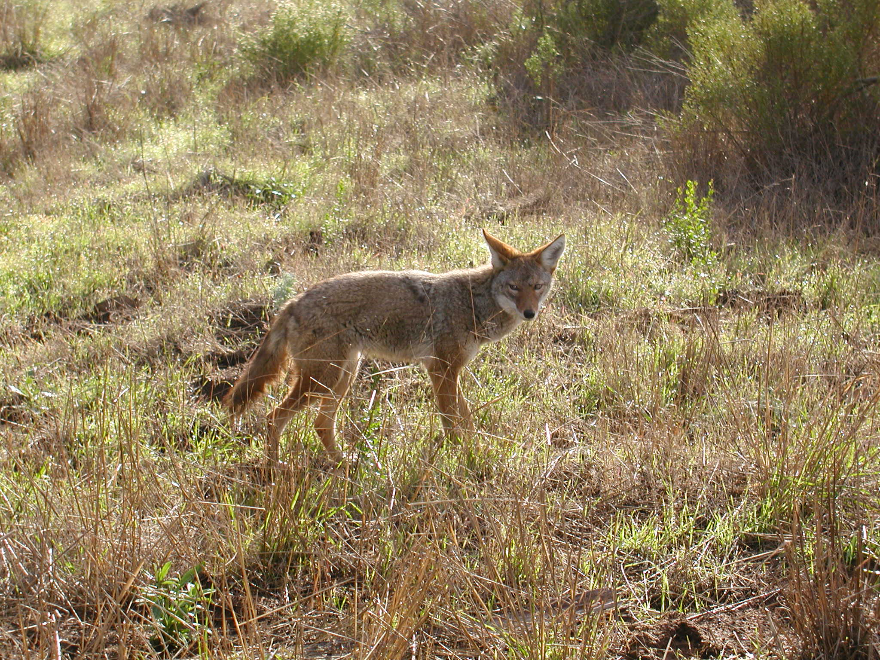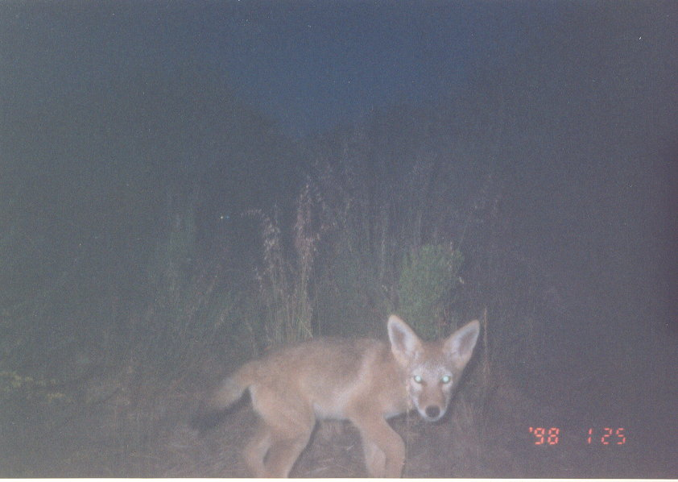
Canis latrans (Coyote) Canis latrans (Young Coyote)
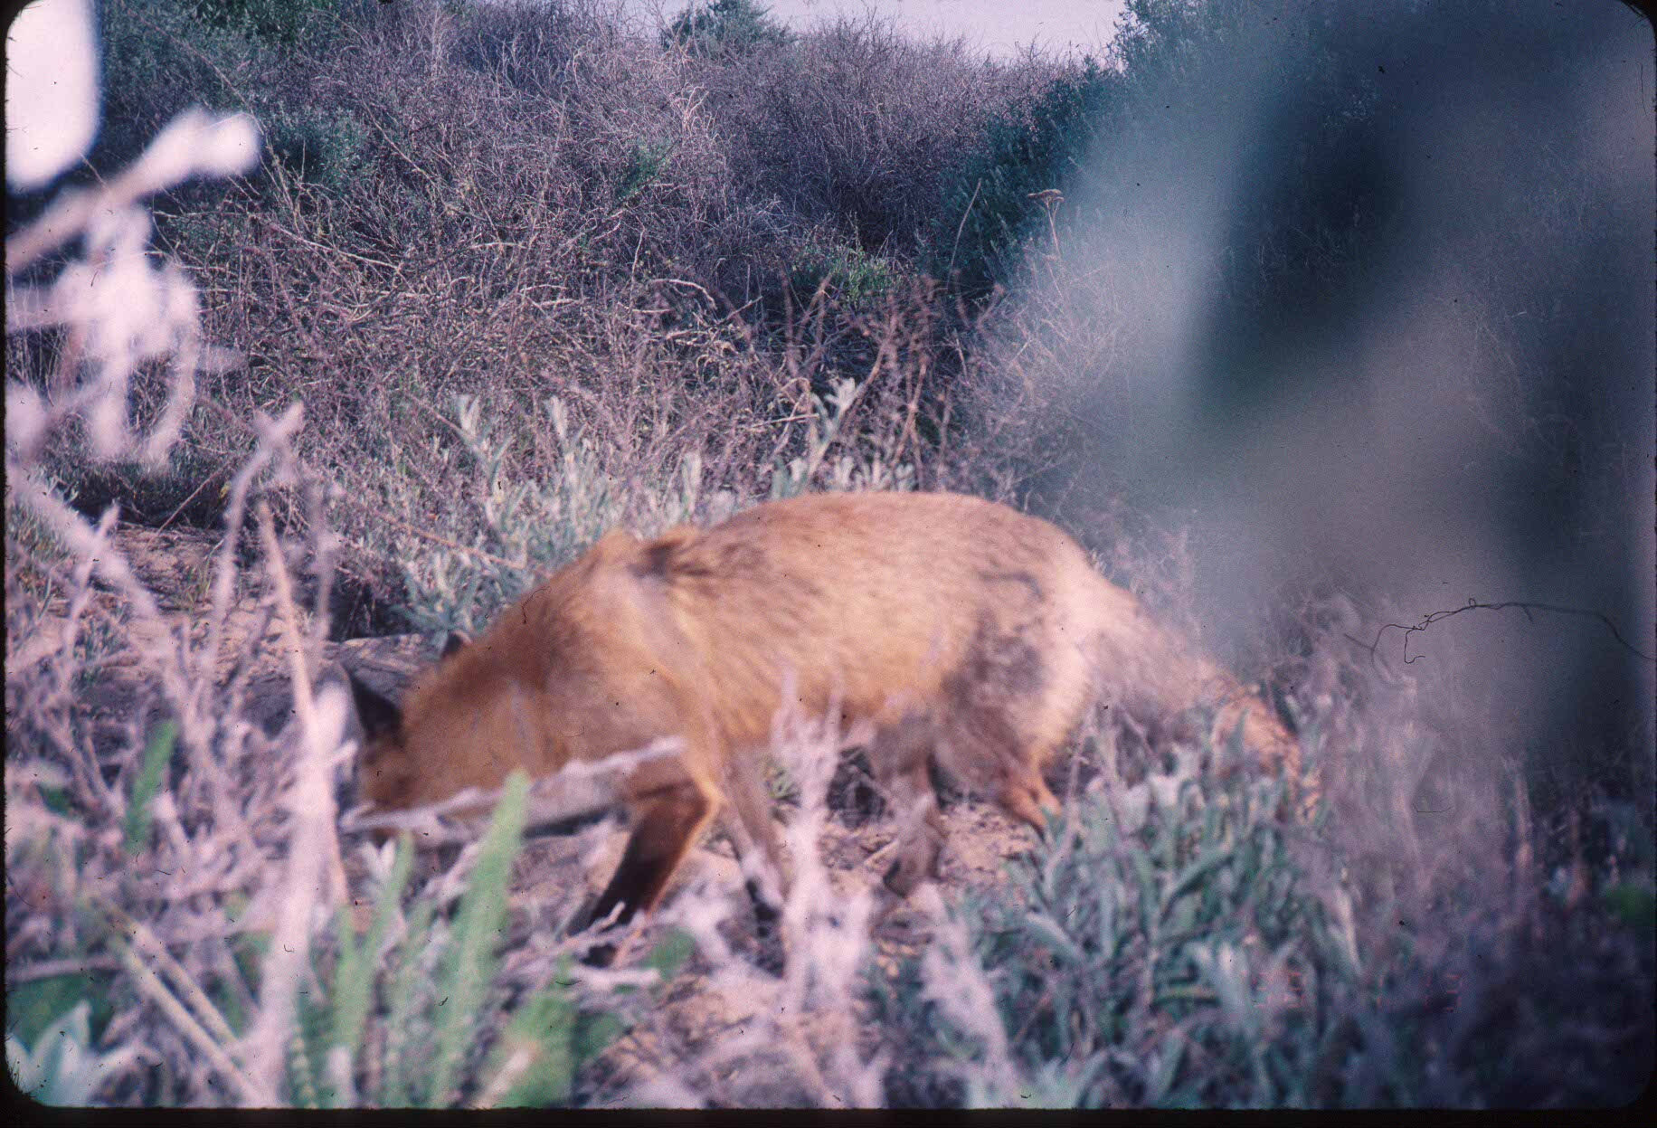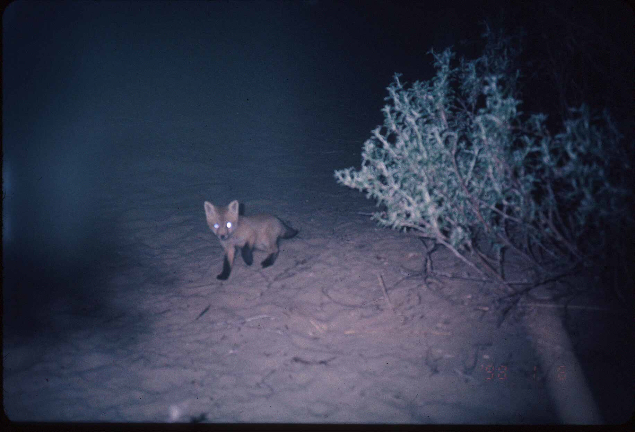
Vulpes vulpes (Introduced Red Fox) Vulpes vulpes (Young Red Fox)
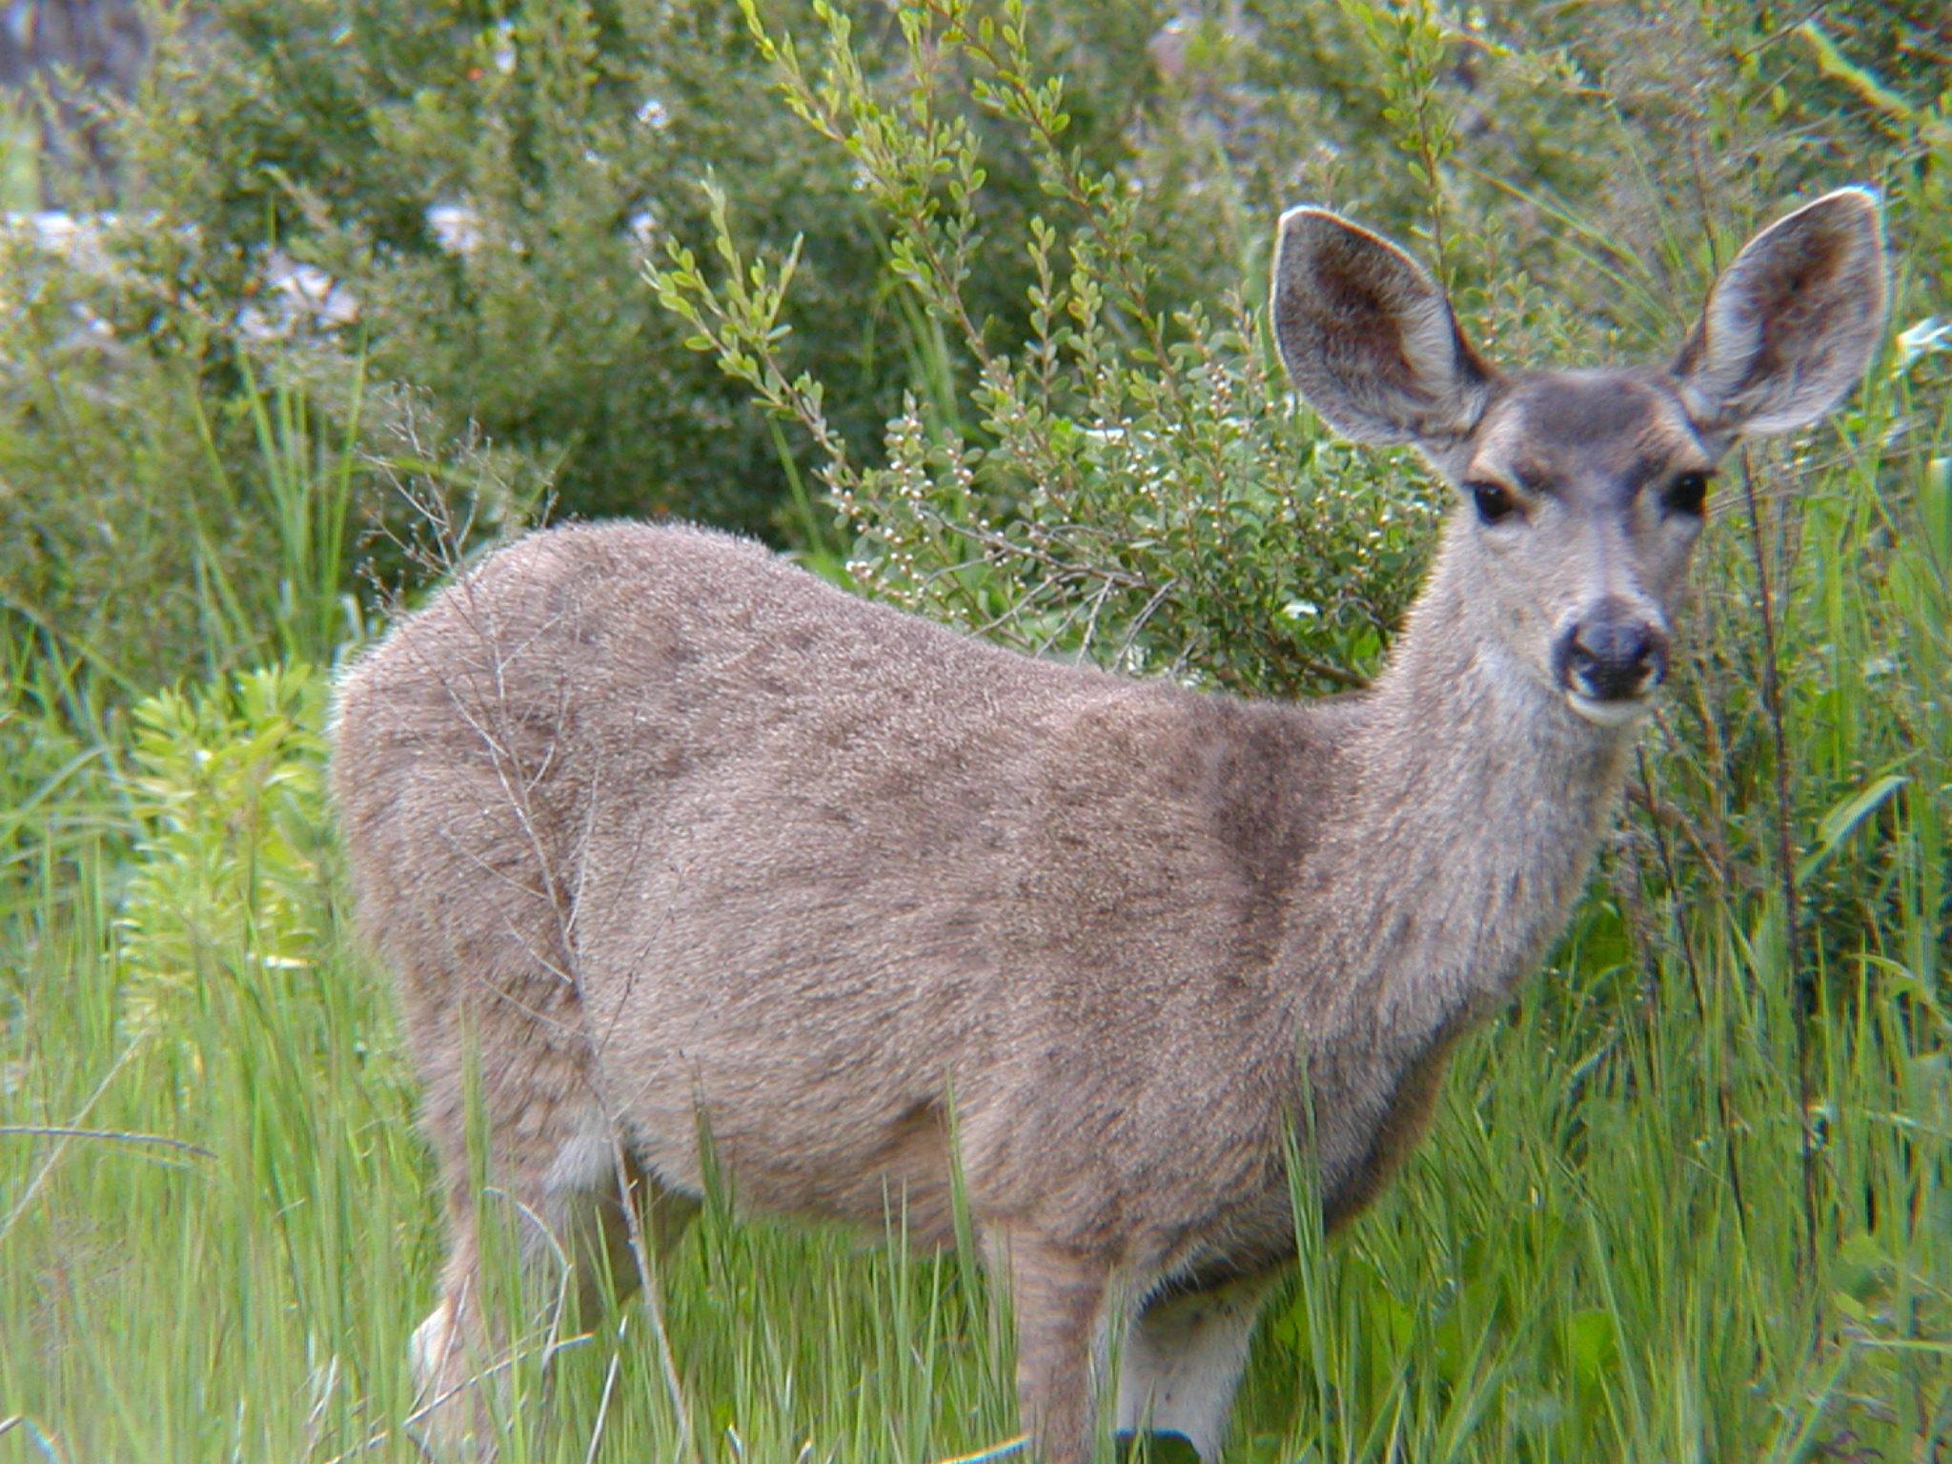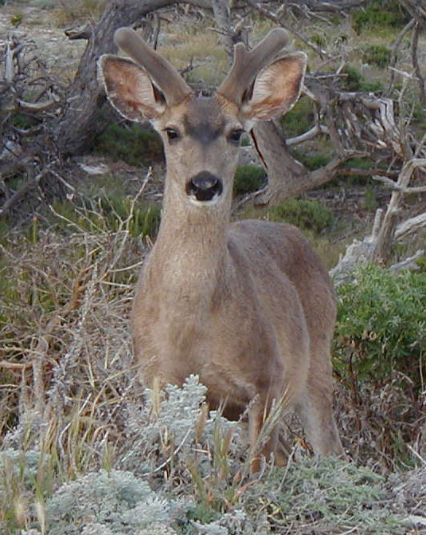
Odocoileus hemionus (Mule Deer Doe) Odocoileus hemionus (Mule Deer Buck)
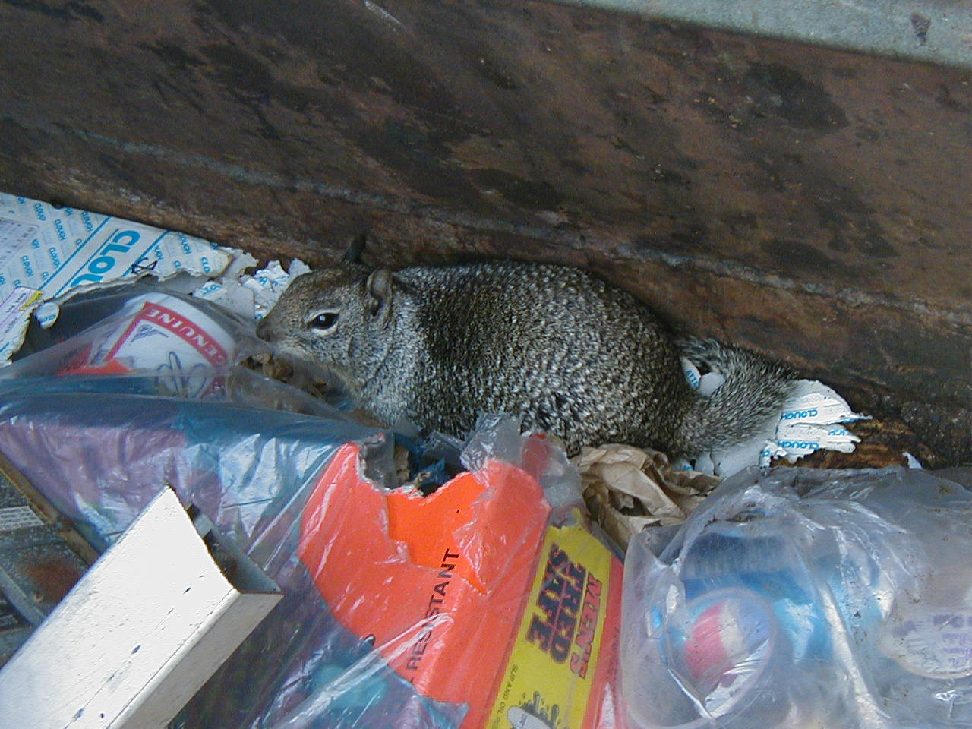
Spermophilus beecheyi(Ca.Ground Squirrel)

